**Project Hazard Control- For Projects with Medium and Higher Risks**

|  |  |  |  |  |  |
| --- | --- | --- | --- | --- | --- |
| **Name of Project:** | | | | **Date of submission:** | |
| **Team member** | | **Phone number** | | **E-mail** | |
| Denis Dineen | | (386) 383-0520 | | [Dad15d@my.fsu.edu](mailto:Dad15d@my.fsu.edu) | |
| Jacob Hutto | | (850) 728-5396 | | [Jih16@my.fsu.edu](mailto:Jih16@my.fsu.edu) | |
| Hunter Kramer | | (850) 273-9299 | | [Hrk16b@my.fsu.edu](mailto:Hrk16b@my.fsu.edu) | |
| Doran McFalls | | (850) 556-1888 | | [Dbm16b@my.fsu.edu](mailto:Dbm16b@my.fsu.edu) | |
| Nicolas Palmeiro | | (305) 812-6715 | | [Nfp15@my.fsu.edu](mailto:Nfp15@my.fsu.edu) | |
| **Faculty mentor** | | **Phone number** | | **E-mail** | |
| Jerris Hooker | | (850) 410-6463 | | [hooker@eng.famu.fsu.edu](mailto:hooker@eng.famu.fsu.edu) | |
| Shayne McConomy | | (850) 410-6624 | | [smcconomy@eng.famu.fsu.edu](mailto:smcconomy@eng.famu.fsu.edu) | |
| **Rewrite the project steps to include all safety measures taken for each step or combination of steps. Be specific (don’t just state “be careful”).** | | | | | |
| **Prototyping**   * Main Risks: Fire started from machines, toxic fumes. * Precautions: Supervised operation, Proper ventilation.   **Assembly**   * Main Risks: Cuts, burns, hearing damage. * Precautions: Wearing eye, ear and hand protection.   **Operation**   * Main Risks: Being struck by device components. * Precautions: Set minimum distance from device and designate safe workspace.   **Testing**   * Main Risks: Electric shock. * Precautions: Use industry approved testing facilities.   **Transportation**   * Main Risks: Being crushed by device, damaging hardware. * Precautions: Using proper moving equipment and training for moving. | | | | | |
| **Thinking about the accidents that have occurred or that you have identified as a risk, describe emergency response procedures to use.** | | | | | |
| In the event of a fire, the team will immediately contact the fire department and then, depending on the severity of the fire either use a fire extinguisher to stop the fire or alert the school and evacuate the building. In the event of inhalation of toxic fumes, the team will contact the poison control center and go to the hospital. For other injuries 911 will be contacted to take care of the issue. | | | | | |
| List emergency response contact information: | | | | | |
| * Call 911 for injuries, fires or other emergency situations * Call your department representative to report a facility concern | | | | | |
| Name | Phone number | | Faculty or other COE emergency contact | | Phone number |
| Florida’s Poison Control Center | 1-800-222-1222 | | Shayne McConomy | | [(850) 410-6624](tel:%28850%29410-6624) |
|  |  | | Donald Hollett | | (850) 410-6600 |
|  |  | |  | |  |
|  |  | |  | |  |

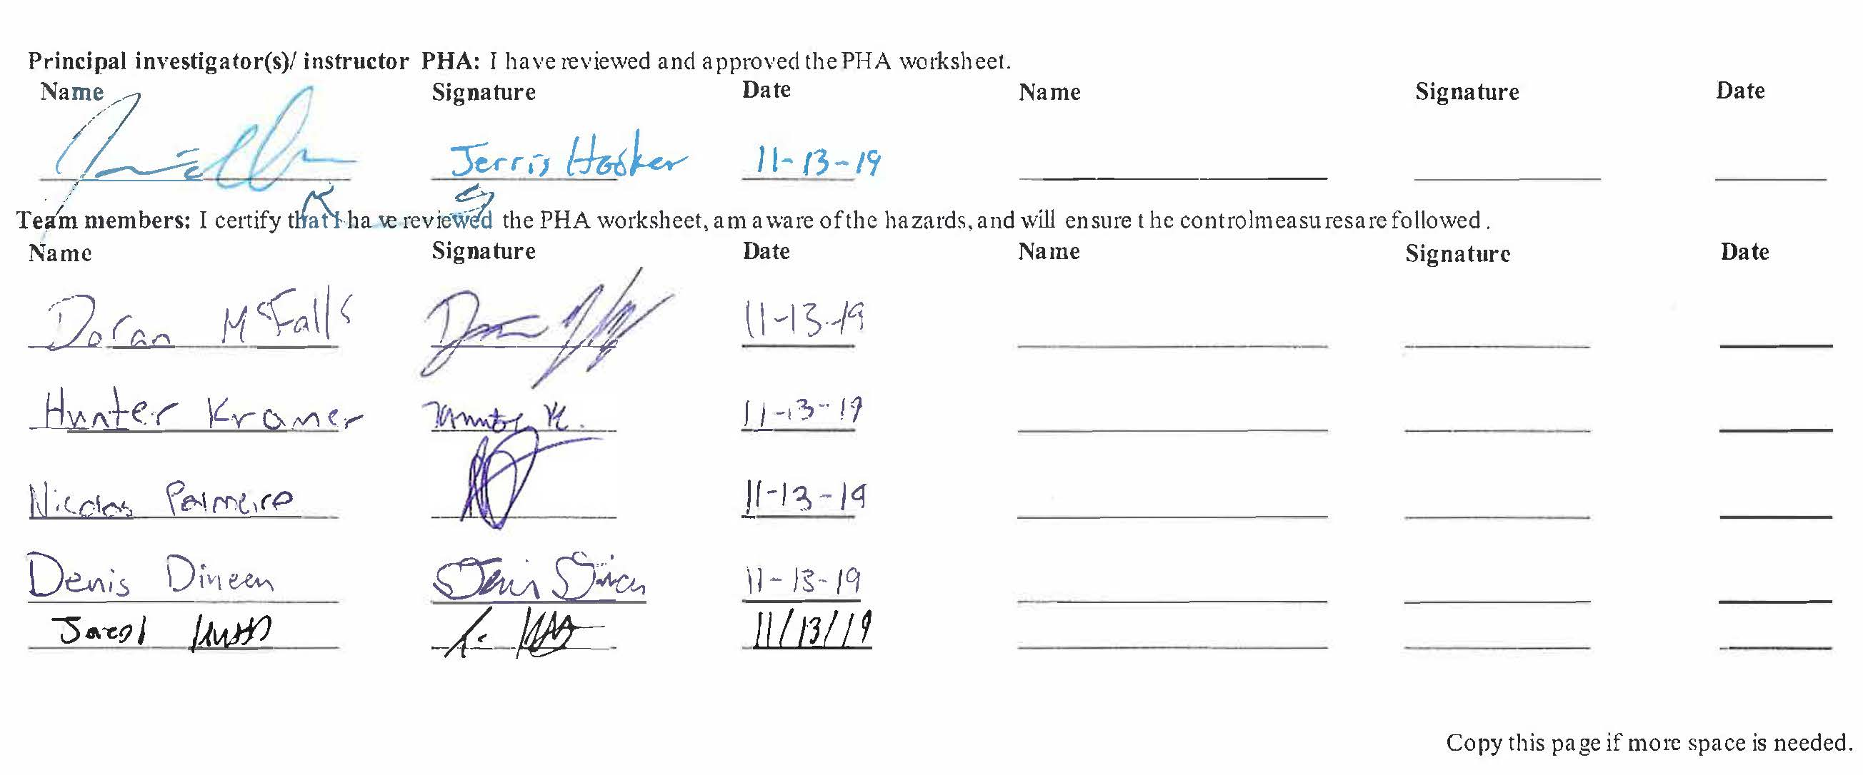

**Report all accidents and near misses to the faculty mentor.**